THE ANGLICAN AND EASTERN CHURCHES
ASSOCIATION

To all members of the AECA -

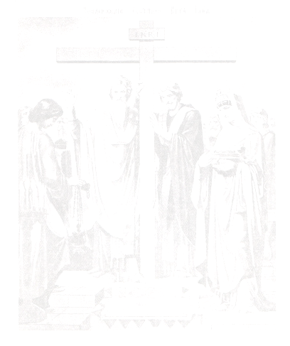
You are warmly invited to the Association’s

ANNUAL MEETING & DINNER

Wednesday 16th September 2020
to be held at

ST SAVA’S SERBIAN ORTHODOX CHURCH
89 Lancaster Road, London, W11 1QQ

6.00 pm Vespers
6.30 pm Annual General Meeting followed by drinks
7.15pm for
7.30 pm Dinner: £30 per person (including two glasses of wine, after which
a cash bar will be available) please see booking form below -
reservations for the dinner must be made by Friday 4th September 2020 (indicating any dietary requirements)

Members may attend for Vespers and the Annual Meeting only if they wish

We look forward to seeing you and hope many will be able to attend.

Dr Dimitris Salapatas
General Secretary
Please return your application, together with a cheque for the appropriate sum for the number of tickets for the dinner to: Dr Dimitris Salapatas, 660 Kenton Rd, Harrow,
Middlesex, HA3 9QN
(Cheques to be made payable to The Anglican & Eastern Churches Association) by Friday 4th September 2020 at the latest. Alternatively e-mail your ticket request to gensec@aeca.org.uk and you can pay the Treasurer by contactless on the evening.

Name …………………………………………………………………………………………………………

Address …………………………………………………………………...........................................

Cheque enclosed for £…….representing ……persons for dinner (at £30 each)
Name(s) of guest(s): ……………………………………………………………………………………..
Dietary requirements:
…………………………………………………………………………………………………………………..
Please note, we will have a RSVP list at the event with names. Tickets will not be sent out to you.

